**DEPARTMENT OF COMPUTER SCIENCE**

**Overcoming Writer’s Block with Word Count Tracking Application**

A dissertation submitted to the University of Bristol in accordance with the requirements of the degree of Bachelor of Science in the Faculty of Engineering.

20th May 2020

# Declaration

This dissertation is submitted to the University of Bristol in accordance with the requirements of the degree of Bachelor of Science in the Faculty of Engineering. It has not been submitted for any other degree or diploma of any examining body. Except where specifically acknowledged, it is all the work of the Author.

# Acknowledgements

I would like to thank my supervisor, Doctor Simon Lock, for his guidance throughout the project. I would also like to thank my friends for testing my application during the hard times of the COVID-19 outbreak.

# Foreword

Writer’s block has been a common issue to all kinds of creators, especially creative writers.

My aims in this project are:

1. To study the causes, impacts and treatment for writer’s block, then making a technological approach to overcome the problem.
2. To develop my app, Writing Blocks, according to this approach.
3. To find out the important aspects of developing an app, like the user interface design and what the users want and expect.
4. To perform analysis on the effectiveness of the app towards writing productivity and prove that it shows improvement.

Based on my research, I suggest that the current technology used to overcome writer’s block is not sufficient and does not have ample rewarding incentive, as well as lacking in user engagement. I argue that an application to overcome writer’s block should have some inclusion of creative or aesthetic elements.

A study is conducted to compare the word counts recorded by participants before and after using the application I develop, Writing Blocks. Results and analysis will then suggest that there will be an increase in word count after using the developed application. The study is also performed and evaluated to gather feedback from participants regarding the general user experience.

Contents

Declaration i

Acknowledgements i

Foreword ii

INTRODUCTION AND BACKGROUND 1

Creative Writing 1

Writer’s Block 1

Survey 2

Causes of Writer’s Block 5

Methods to Overcome Writer’s Block 6

Existing Solutions in Technology 7

My Project Proposal 8

Interfaces 8

Platform 9

Project Management 9

IMPLEMENTATION 10

Time Management 10

Development process 10

Development engine 10

Application Development Process 11

Workload Management 32

User Interface Design 32

APP DEVELOPMENT STUDY 35

Description 35

Effectiveness (Hypothesis) 35

Experimental Design 35

MITIGATION TABLE 42

THESIS CONCLUSION 43

REFERENCES 45

APPENDIX 47

APPENDIX A – FULL ETHICS APPLICATION FORM 47

APPENDIX B – PARTICIPATION INFORMATION SHEET 57

APPENDIX C – WRITER’S BLOCK SURVEY 59

APPENDIX D – CONSENT FORM 62

APPENDIX E – WRITING BLOCKS EVALUATION FORM 64

APPENDIX F – SURVEY FORM WRITTEN RESPONSES 66

APPENDIX G – EVALUATION FORM WRITTEN RESPONSES 69

# INTRODUCTION AND BACKGROUND

## Creative Writing

Creative writing is a type of literature, usually with more emphasis in narration and character development, and less technical, academic, or journalistic. It mainly includes stories, mostly fictional, scripts and poetry, which also extends to the more artistic areas, like songwriting and comic or cartoon storyboarding.

The main idea behind creative writing is for writers to unleash their own creativity and freedom in the form of words. It is to convey a story, expression, feeling or message to the audience who reads it. Creative writing is important to the world, as there is no restriction in thinking, it boosts our minds to more open and further ideas. Creative writing is a kind of art, helping to strengthen one’s soul by giving freedom to express one’s thoughts [1].

However, it is not always the case that writers are able to constantly produce creative works. It can be due to physical health or medical reason, but this can also be caused by a writer’s block.

## Writer’s Block

Writer’s block is, as usually defined, the inability of an author or a creator to write new works. It is not a medical disability, neither disorder nor disease [2]. However, the impact is real to writers, whether it is short-term or long term. Writers can struggle very hard when they do not have the ability to produce work, especially for those who write for a living. Even professionals throughout the history like famous authors, cartoonists and composers had faced this problem. One notable case is of the famous writer of Moby Dick, Herman Meville, who stopped writing novels due to writer’s block [3]. Therefore, this is proven that writer’s block is a common condition to writers and creators.

Writers would feel as if there is a wall built up between them and the ideas or goal they want to reach 2, hence the name writer’s block. Some people would debate if writer’s block is real, where in truth, writer’s block is just like a mental obstacle 2, and the real issues needed to be addressed lie behind the reasons causing it.

There can be several causes to writer’s block, and several ways to overcome it. Ultimately, it depends on the individual themselves, however research and surveys were conducted to find what the majority answers. In the current era of advanced technology where software applications can solve human problems, I decided to research a way to develop an application to address writer’s block and to overcome it. This is one of my goals for my project.

## Survey

Besides doing online research, conducting a survey is a useful, practical, and straightforward approach to gather real life people’s opinions and suggestions. Opinions and suggestions are essential as they are conveying what the audience wants, and the point of developing a software is to create what the audience desires or needs.

However, it is also important to focus on a specific group of people who would be more likely to be interested in my ideas, which in this case they are called the target audience. This is a cost-effective marketing strategy to develop a software as we are focusing on a small group of people who have knowledge or are involved in the field of interest [4].

Hence, I chose the University of Bristol’s Poetry and Creative Writing Club as my target audience. They are writers who are passionate in creative writing and poetry, and naturally they would have some knowledge, opinions, or experience in writer’s block. Some members from the club have been surveyed to express some opinions regarding writer’s block. I used Google Forms to create the survey form as it is a convenient way to gather responses. Below were the questions asked:

1. What kind of writings do you most commonly do?
2. How often do you write?
3. Have you ever experienced writer's block/creativity slowdown/lacking ideas or motivation to write or create?
4. If there is a mobile game that encourages you to write everyday by rewarding you in-game currency for every word per minute and customized goals, how useful do you think this app will be, especially to you? (In-game currency will then allow you to unlock items and characters.)
5. What do you think are the major causes of writer's block? Do you think an application software, or a game can help overcome these problems?
6. Do you have any suggestions to overcome writer's block? If implemented in an app, what kind of features do you think will help?

According to the survey results in Figure 1.1, majority of the club members write novels.

Figure 1.1

As shown in Figure 1.2, the largest percentage, which is around 46%, write more than once a week.

Figure 1.2

In addition, most of the club members have also experienced writer’s block, with a high percentage of 80% and above, according to Figure 1.3.

Figure 1.3

Then, around more than half of them are above average being interested in the idea of the application. Some of them gave reasons as to why they were not interested in it, which I would be using those opinions to develop the application even better. The results are shown in Figure 1.4.

Figure 1.4

After gathering responses from the survey, I listed out the causes of writer’s block and methods to overcome it, as well as whether the majority is interested in having an app that helps overcoming writer’s block. Then, I sorted out the most frequent ideas and opinions, and make them my top priorities to be featured in the app.

## Causes of Writer’s Block

According to the survey conducted, majority of the club members answered that the cause of writer’s block is due to the lack of motivation or confidence, as shown in Figure 1.5.

Figure 1.5

This holds true as the most common causes are due to mental health or neurological disorders [5]. Mental health issues such as depression and anxiety cast self-doubt and hopelessness onto an individual, hence making them lose the confidence, inspiration, or motivation to put out a good work.

In a more neuroscientific explanation, writer’s block is caused by some kind of stress, which the human brain triggers a flight or fight response, where the limbic system takes control instead of the cerebral cortex, where then any creative input from the cerebral cortex is unconsciously hindered as the limbic system takes action in the behaviours of writer’s block instead 3.

Some other notable reasons given by the surveyed people are perfectionism, having a busy schedule or the lack of inspiration and ideas. Especially in the case of perfectionism, writers are pressured either by public or themselves to produce something good, and would set their expectations too high, to the point where nothing would seem to look good in their own eyes. These writers would need to learn to be willing to publish something imperfect, then learn and practice from there [6].

Other reasons given were either more of the impacts of writer’s block, or related to the previous ones mentioned, such as reluctance, procrastination, boredom, having no goals or stress. Procrastination is more of an impact of writer’s block, as it is due to the inability to create works that writers will procrastinate, whether intentionally or not.

## Methods to Overcome Writer’s Block

According to the survey conducted, one of the most common methods the writing club members suggested is to track their word count. Tracking word count is a way of setting individual goals, but easier to manage in numbers. Peter Drucker, a management consultant, said, “You can’t manage what you can’t measure”, it means that quantifying one’s progress is easier and more efficient to manage. It is also easier to show improvement in productivity as a kind of concrete data, in this case, numbers [7].

Another useful method is to have daily writing prompts. It can be generated randomly to kick start some impromptu creativity. This method is useful as it encourages writers to not be afraid of making mistakes. Most importantly, it gets writers to write something than nothing, no matter how good or bad the quality is. This idea is also used in freewriting, where one writes anything that comes to mind in a short amount of time [8]. This is a very useful way to overcome writer’s block for those who have it due to perfectionism or pressure.

Some other notable suggestions the members provided are reading inspirational quotes, getting rewarded for having progress in writing, and not being disturbed by external environment. The suggestion of rewarding for progresses is useful, as it is a sign of encouragement for writers to keep going, they benefit something for overcoming an obstacle and improving themselves [9].

Other minor methods suggested are to write out one’s own thoughts, learn some writing tips, getting inspired by images and checking out NaNoWriMo for ideas. NaNoWriMo, its full name as the National Novel Writing Month, is a month’s project for writers to create content, namely a 50000-word manuscript or novel. This project takes place every November, and it is one of the most popular events for writers. NaNoWriMo also encourages writers to track their progress and it gathers a community of passionate writers to interact and share ideas [10].

A pie chart is created in Figure 1.6 to show a summary of suggestion by the surveyed people.

Figure 1.6

## Existing Solutions in Technology

As gradually more people rely on technology to solve problems, some online tools exist on the web to help with writers to boost their creativity, such as impromptu writing, random title generators and writer community websites. There is also a game to write as much as one can in a limited amount of time, or else they “lose lives” [11].

There is another application called FocusWriter, developed by Catherine Ellis, that allows writers to set a goal, which in this case to track word count, as well as including a spell checker and auto-save function for the works the users are writing [12].

However, there are not many existing technologies to provide aid on overcoming writer’s block, besides the few ones mentioned above, and most of these online tools do not have a rewarding system. According to a theory, the human brain connects rewards with visuals stimuli [13]. These existing technologies without ample visuals stimuli then lack stronger incentive and user engagement. A game would be most ideal to this solution, however focusing on typing in a limited time like the exemplary existing game mentioned above might not be effective for all writers, as each writer has their own way to be motivated in writing. Hence, my approach would be to make a casual, multi-functional mini collection game with the aid of visual aesthetic.

## My Project Proposal

My application, Writing Blocks, is a simple collection game app to track a writer’s word count and reward them in-game coins based on the amount of words. Writers can also customize their own daily goal, and they will be rewarded extra coins if they achieve their goal. However, to not overstress the writers, the game will encourage smaller goals to be made, as the extra coins rewarded will not increase even if the writer decides to increase their daily goal.

Then, with the in-game currency, writers can exchange in-game characters. To make the rewards worth the effort, the exchangeable characters will also focus on being visually attractive or interesting.

Some writers would also prefer taking a break from technology, searching for ideas and inspirations. Some of the surveyed members were not interested in the application, because they thought having it would be intrusive and distracting. Hence, this simple application is meant to be only used approximately 5 minutes every day. All the user needs to do is to just record their word count and if they have enough money, they can buy a character. It will be designed to be non-intrusive so that writers do not get overly distracted by just playing the game and not actually making any progress in writing. As an extra feature, the game will also provide a random prompt generator for writers who need a drive of creativity and inspiration.

The interesting catch behind this prompt generator is that its content depends on the characters bought. Each character is designed based on a literature genre, such as horror or romance. Then, with each character unlocked and collected, the genres of the prompts in the generator expands according to the character genres. For example, if a horror character is bought, horror prompts will be unlocked in the generator. This means when all characters are collected, all the prompts available will be unlocked too.

I planned to design 10 characters based on 10 genres: Horror, Romance, Action, Western, Comedy, Music, Dystopia, Mystery, Fantasy and Sci-Fi. In addition to collecting characters, users can also set their collected favourite character as their main screen mascot.

## Interfaces

As a mini collection game application, it is important to have a user-friendly Graphic User Interface (GUI). GUI mainly includes icons, buttons, menus, visual effects and sometimes sounds. A user-friendly interface is essential to enhancing user experience (UX), as with simple graphical representations it is easier for user to recognize and understand what do to and how to use the application [14].

To make the application interface-friendly and simple to use, there will be a total of 4 layouts planned in this application: the welcome screen, main screen, character shop screen and character collections screen. It is very important to not over complicate the interface design, hence main features such as the word count tracker and prompt generator are featured in the main screen with just one or two buttons needed to click away.

## Platform

Unity will be used to develop the application. This is because Unity is a simple-to-use game engine, not only used to create games, whether in 3-Dimensional or 2-Dimensional, but also to create other state-of-the-art featured technology like Virtual and Augmented Reality. Unity, although its main purpose is to serve as a game engine, also provides professional industries the ability to create films, simulations, constructions and many more. Ever since Unity launched and for fourteen years, the global gaming market had drastically increased by over a hundred billion, expanding not only computer gaming but also the mobile gaming market [15]. It is also available to download for free as a personal edition, with most of the essential features included.

It also allows the application to be exported easily into mobiles, including iOS and Android. For easier testing purposes, I build the application into my own phone’s system, which is Android. To build the application into the phone, the only few steps to do is to install Android Studio, configure some settings, and then set the build paths in Unity to the SDK and JDK folders of Android Studio. Then, by connecting the phone to PC, Unity builds and runs the application directly into the phone.

To write scripts, C# is my main programming language. Implementing the interfaces with Unity’s built in features saves a lot of time, so most of the programming comes from setting up the logic of storing user information like character collections and money management.

## Project Management

As I am working as a solo developer, I decided to risk less by not implementing databases or any sort of online systems. As the application only focuses on individual improvement, it is strived to be simple, easy to use and not time consuming, hence online features are not necessary. However, I will be backing up my files online, such as Google Drive or Github.

# IMPLEMENTATION

### Time Management

The estimated time I worked on this app was around 60 to 70 hours. After coming up with the proposal of this project, I started on my app development in November 2019, and worked for approximately 5 hours for every two weeks.

## Development process

### Development engine

I decided to use Unity 3D as my app development engine but using the 2D UI instead of 3D. Unity uses C# as the main programming language. It is very easy to use and to utilize the code and assets in Unity. The reason I chose Unity as my immediate choice was also partially because I had some experience using it to develop a VR app for a building tour last year.

Other software specifically for mobile app development such as AppSheet or Appy Pie could work. However, I chose Unity as it is versatile, allowing me to not only create mobile apps but also having the choice to expand building other types of applications, such as desktop / PC applications. This was proven useful later during evaluation. I do not own any Apple products, so I was not in any convenient state to build iPhone or Macbook applications. Therefore, as an alternative, I also created a PC version of Writing Blocks, even though it was not originally part of the plan to do so.

Unlike other software, Unity makes things very simple and easy to understand when it comes to creating user interface (UI). Since a good user interface is one of the most important aspects in app development, Unity saves a lot of time as I could just customize the sizes, fonts, colours and many more in the inspector panels given in the development engine. It also breaks down elements into Game Objects and sorts layouts through a simple hierarchy.

How Unity’s objects and scripts work together is that when a script and game object are created, the script can be directly dragged into the inspector of the object, the object is then simply tied to the script. Then, to link the public variables in the script with other objects, I can just drag and drop them into the inspector again. This means that I do not need to manually code the instances of the objects in the script. Figure 2.1 shows how game objects and values are used as public variables of a script.

Figure 2.1

Overall, I am comfortable using Unity as it is complex in its features, yet easy to understand and use.

## Application Development Process

#### Planning and Setting Up

First, I needed to create a new Unity project, then organize and plan what files and folders I needed. Figure 2.2 below shows that I have my assets categorized in folders. The font folder is where I keep the fonts I use, and the scenes folder keeps what is equivalent to the total layouts of the application. The prefab folder contains a scene loader object, which I will have easier access to as this object is used in every scene. There is also a folder to keep my scripts and lastly, a textures folder to store all kinds of sprites and images, like the game characters.

Figure 2.2

#### Implementing Word Count Converter

Although I had some experience with using Unity, it is still my first-time programming in C#. Not having any experience in the language, I quickly followed a simple online tutorial by Jimmy Vegas on how to display input to text in Unity with a C# script to get an idea on the syntax16.

Then, I implemented a function in the script where the number input will be added to the number text. This will be how the word count converts into in-game money. After testing a few times, I then construct a simple interface where when the user clicks the Word Count Record button, an input panel will appear. Once the user inputs the number, they can press the Enter key on their keyboard, the displayed money will then increase. Initially, there was a Confirm button on the input panel. However, when the user taps away from the screen without pressing the confirm button, the input number will still be read and added to the displayed text. I could not figure out why this was the case. Therefore, I adapted and changed it to the case where users should press Enter on the keyboard to confirm the amount instead. These implementations can be found in the **WordcountInput.cs** script.

Figures 2.3 and 2.4 below show how the string input turns into a number and adds its value to the top left corner displayed text.

Figure 2.3 Figure 2.4

#### Creating a Writing Prompt Generator

Creating the generator was simple. All that was needed were a script to randomize some string texts, a button to generate the random text and a panel to display the generated text. The written script for this is in **Prompts.cs**. Figures 2.5 and 2.6 show the text being randomly generated upon button press.

The prompts used in this app were all derived online as examples, as coming up with original prompts will be very time consuming in this case.

Figure 2.5 Figure 2.6

#### Building and Running on Android

After implementing the very first two simple features, I then proceeded to build and test run the application on my phone, which is an Android phone. Adjusting the build settings was a little challenging and time consuming at first. Firstly, according to a tutorial online by Faiid, I had to install Android Studio so that it builds directly into my phone17. It did not work for the first few attempts, so I tried installing Gradle. It did not work for me, but eventually I found my solution by just adding the SDK and JDK paths in the project external tools preferences.

After that, I turned on the debug setting on my phone and directly built the app into it via a cable.

Figure 2.7 shows the SDK and JDK paths I had added to build and run the app.

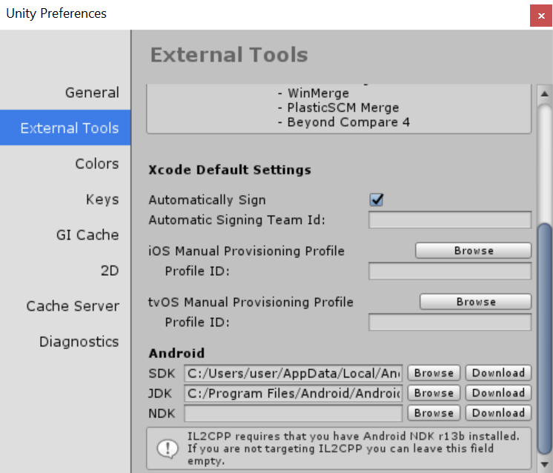

Figure 2.7

#### Creating the Main Scene Interface

The main scene of the app is where the main features will be, such as the word count recorder, the writing prompts generator, buttons to the character shop and collections and so on. This will be the second scene the users see upon first using the app. Figure 2.8 below shows how the buttons, text and the character mascot are placed. I am using a colour scheme of monochromatic colours and red, as these colours are contrasting, easy to distinguish and to look at. Too many complex colours will strain the user’s eyes.

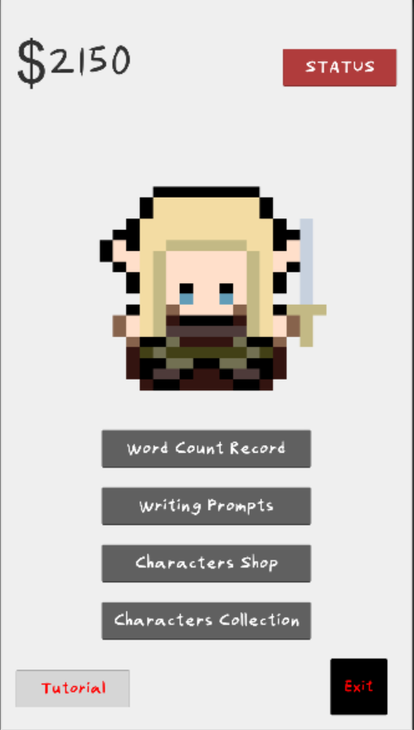

Figure 2.8

#### Creating the Welcome Scene

The welcome scene is just a simple interface to welcome the user when the user first opens the app. The character mascot will stand in the middle and the user only needs to click “Tap here to Enter” to proceed to the main scene. To enter the main scene, a simple scene loader is used (see **SceneLoader.cs**). The welcome scene interface design should be as simple as the purpose it serves. Figure 2.9 shows the interface design of this scene.

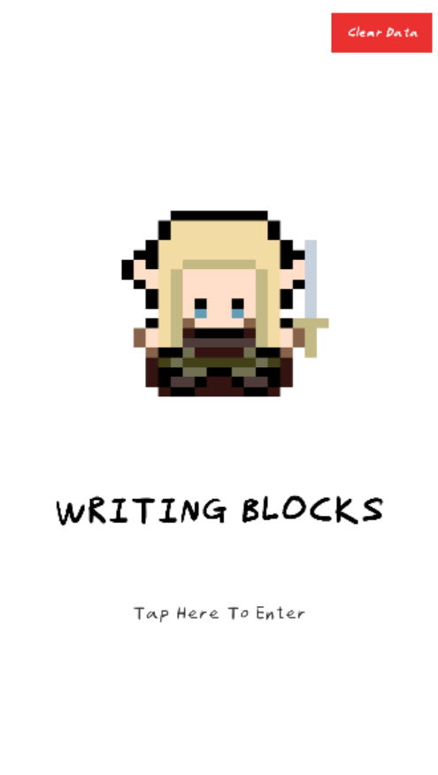

Figure 2.9

#### Creating a Character Shop

Next, I implemented the character shop, where users can use the money, which they have converted from recording their word count, to buy characters. This was one of the parts which took me the longest to code, as I not only was not familiar with programming in Unity C#, but also because there was a lot more things to consider in this scene. Code Monkey on Youtube made amazing tutorials on creating a Unity 2D game, so I closely followed his tutorial to set up a shop18.

The idea behind the interface of this scene is when the characters are displayed in the shop panel, the sprites are cloned from the script, instead of manually creating game objects for each character sprite. Figure 2.10 shows that before running the app in Unity, there is only one character’s sprite. This character sprite is in a transformation container. Then, when the app runs, the container duplicates from left to right and up to down, from there I used a game object containing different character sprites and link it to the Shop script. The prices and names of each character differs too. These are all stored in the **Characters.cs** script, and the character sprites are defined in **CharacterAssets.cs**. By creating a game object linked to this script, the **Shop.cs** script can then link its Characters variable to this game object as well.

Figure 2.10

Additionally, when a character is bought, a large “SOLD” text will cover over the character, this means users can only buy once of the same character. When the user does not have enough money to buy a character, a large “NOT ENOUGH MONEY” text will cover the character as well, indicating that the user cannot buy the character until they write more and earn enough money. With the big text covering the character sprite, it is a great and easy way to not need to display any error messages when the user tries to click onto the character sprite to buy the character. Figure 2.11 shows how the characters and texts are displayed when the app is running.

Figure 2.11

When buying a character, the user can click onto the character sprite. This will bring the user to another panel where the user confirms to buy the said character. This is necessary as if users accidentally click onto a character sprite, they can go back and choose their character again and not spend their money on a character they do not desire to buy. It is important as once a character is sold, there will be no refunds. When the user confirms to buy a character, a confirmation panel will then appear. Of course, the money decreases as well, according to the price of the said character. The money the user has will always be displayed on the top left corner. By clicking the “BACK” button, users can then continue to shop for more characters.

Figure 2.12 and 2.13 show the process of buying a Romance character.

Figure 2.12 Figure 2.13

When a character is bought and the user returns to the character shop’s main panel, a Boolean flag for the bought character in the script will be set to true, indicating that the character is sold. With the Boolean flag set to true, the “SOLD” text will then cover over the character sprite. Figure 2.14 shows how the Romance character is now sold.

Figure 2.14

#### Creating Pixel Characters

There is a total of 10 characters. These character designs are based on story genres and widely known fictional characters who are linked to each of these genres. These are the 10 characters used in Writing Blocks and the inspired fictional characters tied to their genre names:

1. Fantasy – Legolas from Lord of the Rings
2. Romance – Cupid
3. Comedy – Mr. Bean
4. Horror – Sadako, a kind of Japanese ghost
5. Music – Beethoven
6. Mystery – Sherlock Holmes
7. Action – Bruce Lee, a famous Hong Kong actor
8. Dystopia – Katniss Everdeen, protagonist of The Hunger Games
9. Western – A cowboy
10. Sci-Fi – Darth Vader from Star Wars

All these characters were drawn by me using an art program called SAI Paint Tool. Although I do have the artistic ability to draw realistic or cartoon characters, I chose to create the characters in a pixelated art style, as it is a useful style to save time without looking any less attractive. However, the style was inspired by the retro games of Pokemon. Pokemon (Pocket Monsters) is a popular video game originated from Japan and is well-known worldwide.

It is important that users can recognize these characters despite its simplified pixel style. For example, the Fantasy character has a sword, the Music character has musical notes and so on.

Figure 2.15 shows a pixel sprite from Pokemon, and Figure 2.16 shows my process of making these characters.



Figure 2.15

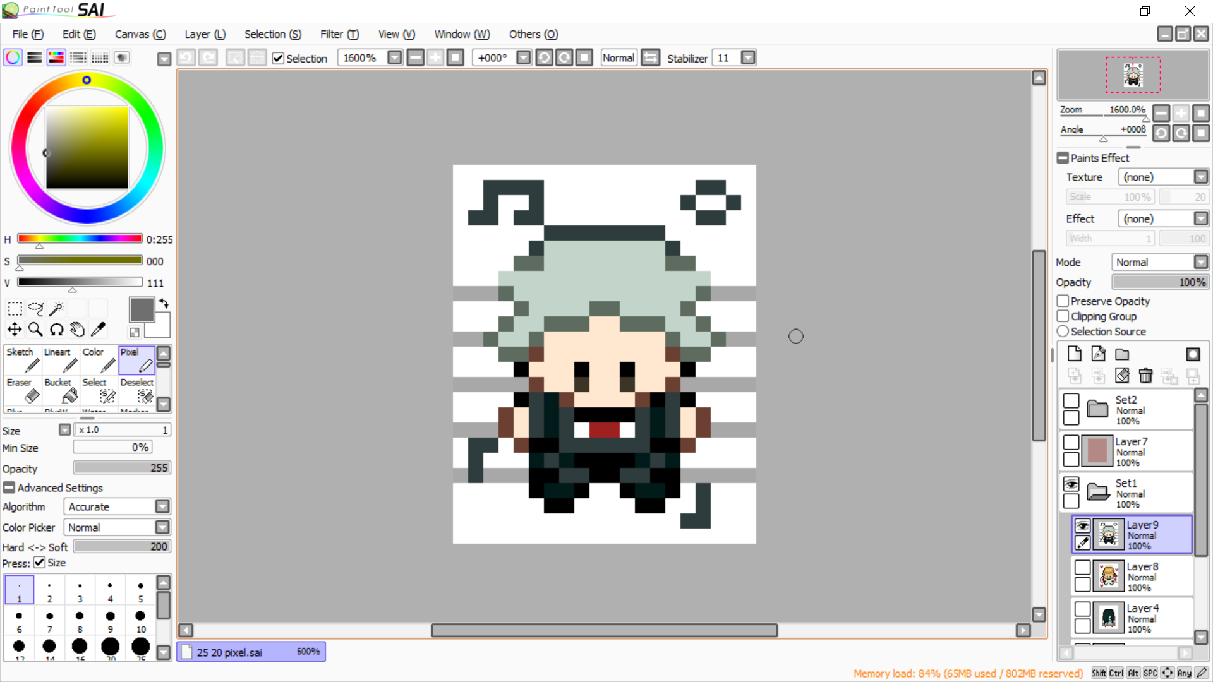

Figure 2.16

#### Creating a Character Collections Scene

Implementing the character collections scene is like the shop scene, as I would need to clone character containers from the code as well. There are some differences, of course. For example, no money is needed to be displayed or calculated, and when no characters have been bought yet, the collections panel stays empty. When users enter this scene, the **UI_Collections.cs** script will check if there are any characters bought. It then displays whichever characters that have been bought previously. Figure 2.17 shows a few characters collected.

Figure 2.17

#### Saving and Deleting Data

Data management is simple to implement in Unity with PlayerPrefs. PlayerPrefs only requires three types of actions: Get Data, Set Data and Delete Data.

Of course, the most important data that needs to be saved are the money and the character collections. If those are refreshed every time the user reopens the game, there will be no point to the earning and rewarding system.

Then, users can choose to reset data in the welcome scene. Although it seems unlikely that users would want to reset everything and clear all their hard-earned money as well as the characters, this was a very useful and time-saving method for me to debug the app, as I started implementing PlayerPrefs to save data. I would need to reset the data repeatedly to check and debug any problems with the app.

Figures 2.18 and 2.19 show how data can be cleared.

Figure 2.18 Figure 2.19

There is a bug where all data can only be cleared when the confirm button is clicked twice without changing scenes. I could not successfully debug it; therefore, I took an approach where the users would need to click the button twice as the requirement to delete all the data. In a way, this is also a good way to prevent users from accidentally deleting their data. Needing to click the button twice serves a second chance for the users to keep their old data.

#### Implementing Mascots

The idea is to have users choose their favourite character to be displayed in the main and welcome scene. In the collections scene, when the user taps on a character sprite, a panel will appear to ask if the user would like to set the selected character as the mascot. By confirming it, the character will then appear in the main and welcome scene. Entering the main and welcome scenes, again, Boolean flags will check if a specific character mascot is set and will display the mascot according to the Boolean flags. These are all implemented in **Mascot.cs**. Figures 2.20, 2.21 and 2.22 below show the process of setting the mascot.

Figure 2.20 Figure 2.21

Figure 2.22

#### Status (Timer, Total Word Count, Daily Goal)

Users can check their status, such as the total words they have written and their daily word count goal in the status panel. The status button is shown on the top right screen in red to indicate its importance. In the status panel, the current time, daily goal, and total word count will be shown. Users can also set and change their daily goal in this panel. Like the word count record input, users will have to press the Enter key on their keyboard to confirm the amount of their daily goal. Figure 2.23 shows the layout of the status panel, and figures 2.24 and 2.25 show how to set the daily goal. These are implemented in **SetGoal.cs**.

Figure 2.23

Figure 2.24 Figure 2.25

When users record their word count and the daily goal is achieved, users will get an extra $50. After achieving their daily goal, users will not get anymore extra money for the next 24 hours. This is implemented using a timer, which I had to also follow a tutorial on how to track time (see **ClockUI.cs** and **TimeManager.cs**) 19. Figures 2.26 and 2.27 show how the daily goal reward is given.

Figure 2.26 Figure 2.27

#### Additional Features (Enhancing Prompt Generator, Inspirational Quotes)

I then implemented a few more simple features to make the app a little more interesting. First, I enhanced the writing prompt generator, where when a character is bought, more writing prompts will be unlocked. The unlocked prompts are based on which characters are bought. For example, buying the Romance character will unlock romance genre writing prompts. This will make users who are more interested in the writing prompts to be more motivated to collect more characters, so that they will have varying genres of prompts to write about. So far, there are 65 basic prompts without buying any characters. If all characters are bought, there will be a total of 230 prompts unlocked.

Then, I also added a pixelated speech bubble for the mascots to “talk” when the users tap on them. The speech bubble will contain a randomized inspirational quote about writing and will appear for 5 seconds before disappearing automatically. When the user taps on the mascot again, the speech bubble appears again but with a different randomized quote. I had added this feature as according to the survey, some writers would like to be motivated by inspiring quotes. Generating the quotes is the same concept as generating the writing prompts (see **Quotes.cs**).

Figure 2.28 shows how the speech bubble pops out when the mascot is tapped.

Figure 2.28

#### Adjusting and Enhancing Interface (Fonts and Colours)

During my development process, I had asked a few people to test the prototype of the app. Some people gave the feedback where the font was quite hard to read. The font I originally used was Fineliner, a font I simply downloaded when I was following a tutorial to set up my Unity project17. It turns out the cursive writing was hard for users to distinguish the letters. Hence, I changed the font to C6010-Regular, which is my own handwriting converted into a font.

I had also changed some of the panels’ colour to black instead of gray to create a more distinguishable and contrasted look.

Figures 2.29 and 2.30 show an example of the before and after appearances of a panel.

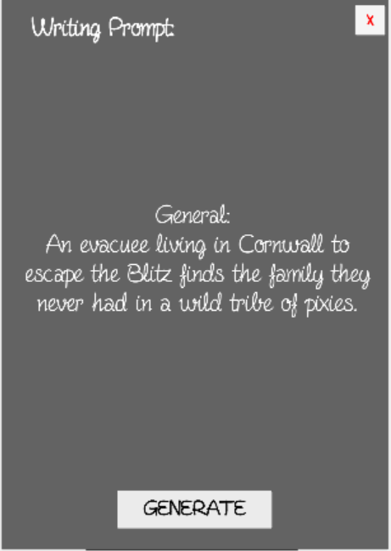

Figure 2.29 Figure 2.30

#### Changes and Updates in Development of the App

During the process of developing the app, I had gone through a few changes for it:

* Adding inspirational quotes
  + I did not include inspirational quotes as part of my proposal because I did not figure out where I could ideally place them back then. It was during the development process that I figured I could make the mascots “speak” the quotes.
* Adding a tutorial panel
  + Towards the end of the development process, a few users gave the feedback where they did not know about the underlying and unexplained features such as the daily goal reward, the mascot setting and so on. Realizing that I did not give the users a tutorial or guide in advance, I quickly created a tutorial panel in the app, with its button at the bottom left corner of the main scene. The tutorial of the app is only explained in text in a long scroll view. I could not give the test users a live demonstration or tutorial due to the COVID-19 outbreak and country lockdown. Figure 2.31 shows the tutorial panel upon tapping the tutorial button.

Figure 2.31

* Adding a PC version
  + Due to the lockdown, I had to let participants test out the app by downloading the app themselves instead of doing a live demonstration. Therefore, there were cases were users were unable to use the app because their phones are not Android phones. Writing Blocks was only built for Android phones. Hence, I created a PC version by the last minute, just for users who at least have a Windows desktop to test the app. The PC version functions exactly the same as the mobile version, but in a different resolution and layout arrangements. Figure 2.32 shows the interface of the main screen of the PC version.

Figure 2.32

## Workload Management

I had prepared a backup of my projects and assets on a Google Drive and on Github. As for organizing my work for this project, I made a short list of things I would like to do in sequence, from surveying to a step by step list of implementation, and then I tried to follow the list by working on the project for an average of 2 hours per week.

## User Interface Design

Besides writing clean and “dry” codes, and making the algorithms behind the app system work, the user interface design is also vital in app development. No matter how well written and developed is the app, it would still be impractical if users do not have easy access to the app features.

Here, I will reference the “10 Rules to a Good User Interface Design”, written by B.J. Keeton20, and explain how these rules were applied in the app. Although the article specified for every web design project, the same will still apply in any kinds of application development or design in general.

1. Necessities are Readily Accessible
   * The main features of the app, such as the word count record and the buttons leading to the shop and collection pages are shown in the middle of the main scene for users to access straightforwardly, and not hidden elsewhere.
2. Consistency
   * The app only uses one type of font, as using too many fonts may confuse the users. By standard, the body text should only stick to one type of font, and another font for the headers and so on. However, I decided to just use one font for everything.
3. Clarity
   * Users should know what each feature does. For example, when a character is bought, a big “SOLD” text will cover over the character sprite. Also, in the prompt generator, the panel starts off by telling the users to “Generate Me”, so the users would know that they should click the GENERATE button to generate a random writing prompt.
   * However, I failed to present a good way to show how the daily word count goal works. I had then created a tutorial panel to further clarify all the features of the app.
4. Feedback
   * The app should respond whenever it performs an action, to let the users know what has happened. For example, in the character shop scene, when the user buys a character, a panel will show up with a message saying that the character has been bought. Another example is when the user inputs their word count and reaches their daily goal, a message will appear indicating that the goal is reached.
5. Use Recognition, Not Recall
   * Buttons should be designed in a way that the user can recognize their uses. For example, the Exit button in the main scene is the smallest button, and the Close buttons are designed as a small red X at the top right corner of each panel, indicating that it is a close panel button.
6. How People Interact with the Device
   * This is especially important for mobile apps. Writing Blocks was designed in a portrait (vertical) resolution of 1080x1920. This is because usually, mobile phone users will hold their phones vertically, and very less likely horizontally. It is also common for smartphone users to swipe their screens or slide their finger on it. Therefore, the character shop, collections and tutorial panel have a scroll view for the users to slide their finger to scroll, instead of using up and down viewing buttons.
   * It is also important to note that users interact with their phones mostly with their thumbs, and judging by the position their thumbs are placed, it is always on the bottom half of the screen. This is also why in the main scene, the buttons are below the mascot, and not the other way around.
7. Conventional Design Standards
   * As mentioned above, the close panel buttons are designed as a small red X on the top right of the panel. This is because this design has been widely known as the “close window” button, and it would not be wise to go against the norm.
8. Elemental Hierarchy
   * This depends on the importance of every single element. For example, in the main scene, the mascot is shown in the middle and takes up half the space of the scene. This is because as a mascot, its purpose is to stand out aesthetically and strikingly. In Writing Blocks, the money will also always display on the top left corner. Also, the Status button is red and placed at the top right of the scene, indicating that it is information equally important as the money displayed, and it serves a slightly different purpose from the other buttons.
9. Simplicity
   * As mentioned before, a cluttered or complex interface can confuse the users. In Writing Blocks, the interface elements are mostly aligned and spaced out so that they do not look cluttered. Also, as mentioned previously, Writing Blocks follows the simple colour scheme of only red and monochrome colours. This is to prevent users from getting confused as to which colours indicate elements that stand out more, in this case, red is the only colour that will stand out from the monochrome colours such as white, grey, and black.
10. Users have Freedom and are In Control
    * Users should not feel restricted when using an app. Although Writing Blocks does not allow refunding bought characters, users still have the choice to confirm their purchase, in the case of accidentally tapping onto a character sprite.

# APP DEVELOPMENT STUDY

## Description

Participants are asked to download Writing Blocks themselves, either the APK file or the PC application to test out the application. Then, they are asked to fill in an evaluation form to give a review on how is the user experience and the effectiveness in writing productivity, as well as giving feedback on what has been done well and what needs to be further improved.

Initially, a live demonstration was going to be given to test the effectiveness of using the app with or without a live tutorial. However due to the COVID-19 outbreak and country lockdown, this became impossible.

As this study requires some form of human participation in testing the app on their own devices as well as giving out feedback and reviews, I had to fill in an ethics application online. This project has been ethically approved by the Research and Enterprise Development’s Ethics Online Tool.

## Effectiveness (Hypothesis)

Participants who used the app will have an improvement in writing productivity compared to before using the app. To be precise, the word count after using the app will increase.

## Experimental Design

#### Experiment Procedure

1. Participants are given a consent form to sign. This is because this research needs human participation to test the app, and hence the app needs to be ethically consented before using.
2. After that, participants are given the link to the Google Drive containing the APK file and PC version of the app, and the link to fill in the evaluation form.
3. Participants should ideally have previous writing experience and record their word count before testing the app.
4. Participants then download the files into either their phone or Desktop to test out the app, and record their newest word count as they use the app.
5. Finally, participants fill out the evaluation form to give feedback on the app.

#### Variables

Independent variables:

* Status before using Writing Blocks
* Status after using Writing Blocks

Dependent variables:

* Word Count Record

#### Participants

Participants were originally planned to be the members from University of Bristol’s Poetry and Creative Writing Society. A live demonstration was planned to be performed during one of the writing sessions. Unfortunately, due to the lockdown, the demonstration could not happen, and I could not get enough attention on social media groups.

Hence, participants are of random acquaintances and friends, where a couple of them do write more diligently and hence have previous word count records before using Writing Blocks.

#### Improvement Percentage

An improvement percentage is calculated to determine how much a participant has improved in writing productivity. The formula is as below:

***Improvement Percentage, I% = Average Word Count Difference / Average Word Count Before Using the App * 100%***

#### Results

A total of 8 participants had tested and evaluated the app. However, only 3 had given their word count data.

#### Productivity Results

Table 3.1 and Figure 3.1 show the results of three participants’ word count records and the average word counts.

|  |  |  |  |
| --- | --- | --- | --- |
| Word count | Word count before using the app | Word count after using the app | Word count difference |
| Participant 1 | 1500 | 2100 | 600 |
| Participant 2 | 500 | 1000 | 500 |
| Participant 3 | 500 | 950 | 450 |
| **Average** | **833** | **1350** | **517** |

Table 3.1

Figure 3.1

The improvement percentage is then calculated using the formula mentioned above,

***I = 517/833 * 100%***

***I = 62%***

#### Statistical Significance

Calculating only the improvement percentage is insufficient, as I would need to further analyze the data to find out if the difference between the word count before and after using the app is significant, and also to find out if I had enough participants in this study to perform accurate analysis.

I used a program called SPSS to record and run analysis tests on my data.

##### *ShapiroWilk Test*

After gathering the data, I wanted to find out its statistical significance. To test this, I had to first determine if the data was normally distributed, as the test to calculate statistical significance will depend on this. I used the ShapiroWilk test to run on the word count data, for both statuses of before and after using Writing Blocks. The null hypothesis states that the data is normally distributed.

According to Table 3.2 below, the red text shows that only the word counts after using the application has a significance level higher than 5%, which in this case is 7.3%, and there is 0 p-value for the word count data before using Writing Blocks. This means that the word count data after using the app is normally distributed, whereas the ones before using it is significantly deviated from being normally distributed. Therefore, the null hypothesis could be accepted.

|  |  |  |  |  |  |  |  |
| --- | --- | --- | --- | --- | --- | --- | --- |
| **Tests of Normality** | | | | | | | |
|  | Status (Before/After) | Kolmogorov-Smirnova | | | Shapiro-Wilk | | |
|  | Statistic | df | Sig. | Statistic | df | Sig. |
| Word Count | Before | .385 | 3 | . | .750 | 3 | .000 |
| After | .372 | 3 | . | .783 | 3 | .073 |
| a. Lilliefors Significance Correction | | | | | | | |

Table 3.2

##### *One-way ANOVA (Analysis of Variance)*

Next, I used a one-way ANOVA, which is an Analysis of Variance test to check the significant difference in the condition of before and after using Writing Blocks. According to Table 3.3 below, the results state that there is a p-value of more than 0.05, which is 0.361, shown in red text. This means that there is no significant result.

Not only that, the table shows that the observed power to the test is only 12.7%, shown in blue text. This observed power defines the probability of detection of a significant difference. Since the probability is very low, it proves that the number of participants who evaluated the app and provided their word count record is simply insufficient.

|  |  |  |  |  |  |  |  |  |
| --- | --- | --- | --- | --- | --- | --- | --- | --- |
| **Tests of Between-Subjects Effects** | | | | | | | | |
| Dependent Variable: Word Count | | | | | | | | |
| Source | Type III Sum of Squares | df | Mean Square | F | Sig. | Partial Eta Squared | Noncent. Parameter | Observed Powerb |
| Corrected Model | 400416.667a | 1 | 400416.667 | 1.060 | .361 | .209 | 1.060 | .127 |
| Intercept | 7150416.667 | 1 | 7150416.667 | 18.921 | .012 | .825 | 18.921 | .894 |
| Status | 400416.667 | 1 | 400416.667 | 1.060 | .361 | .209 | 1.060 | .127 |
| Error | 1511666.667 | 4 | 377916.667 |  |  |  |  |  |
| Total | 9062500.000 | 6 |  |  |  |  |  |  |
| Corrected Total | 1912083.333 | 5 |  |  |  |  |  |  |
| a. R Squared = .209 (Adjusted R Squared = .012) | | | | | | | | |
| b. Computed using alpha = .05 | | | | | | | | |

Table 3.3

#### Questionnaire Results

Figure 3.2 below shows that participants have an above average user experience when using the app, from a rating of 1 (bad) to 5 (great).

As shown below, the user experience has an average rating of 3.9 over 5.

Figure 3.2

Figure 3.3 below shows that most participants think the app has average or above potential to overcome writer’s block, from a rating of 1 (useless) to 5 (useful).

As shown, it has an average rating of 3.35 over 5.

Figure 3.3

Participants also answered a few long answer questions as below:

**QUESTION:** What are the strong points of this app (if any)?

* **RESPONSES:** Most of the participants were pleased by the aesthetic and the character art. They also thought that the rewarding system to earn buy characters is interesting and motivational.

**QUESTION:** Are there any other features you would like to see in this application (besides adding in more characters)?

* **RESPONSES:** Each response had given a very different suggestion. Some suggested having more rewards, like character backstories, wallpapers, and more daily reward money. Others suggested having additional features like notetaking, a desktop version (which I implemented it in the end), and graphs to track word count productivity and progress.

**QUESTION:** What can you suggest to further improve or develop the application?

* **RESPONSES:** The first few participants stated that the UI needed improvement, mainly the controls, and font was hard to read. I had changed the font and colours later, as well as adding a tutorial panel so that they would understand how the controls and features worked. Others suggested the app to be either more interactive or have more additional features like mentioned in the previous question.

#### Study Conclusion

As calculated above, participants will have an average writing improvement of 62%, which means writers would write 162% of their usual amount. It is considered an above average improvement.

However, this is not an accurate enough data as there were only three participants involved. In data science, it is fundamental that the more data we have to a certain extent, the more accurate the information is. The insufficient number of participants has been proven by the ANOVA test, showing a low probability of 12.7% regarding the detection of significant difference in data.

If the study were to be conducted again, I would have done a few things a lot differently:

1. Firstly, I should had gone through a prototype test and get a few feedbacks before letting participants officially evaluate the app. This is because I changed the font and colours halfway through the evaluation process.
2. I should have also considered a desktop version since the beginning, as well as finding a way to build the app for different operating systems.
3. Lastly, I did not have participants attempt to do a free writing session in advance before using Writing Blocks, which I should have, so that I have more concrete data to calculate and perform analysis on.

Concisely, I would need to plan further and in advance when it comes to experiments and its study, and not just about focusing on constructing the app.

# MITIGATION TABLE

Due to the COVID-19 outbreak and country lockdown, departments had been closed, and outdoor activities had been canceled. This had led to a few difficulties for me to conduct my research project. Hence, the mitigation table below is shown to explain the issues I faced, its impacts and the actions I took.

|  |  |  |  |
| --- | --- | --- | --- |
| Event/Issue | Potential/actual Impact on project | Action(s) taken to mitigate impact on project outcomes | Remaining impact |
| No live demonstration of the project could be performed to writer participants due to lockdown and cancellation of society activities. | Key data which is the word count record from writers could not be obtained directly from the group of participants. | Gathered as many participants and data as possible. | Insufficient metrical data to perform analysis on the effectiveness of the app. |

# THESIS CONCLUSION

My main goals for this thesis, mentioned in the foreword, were:

1. To study the causes, impacts and treatment for writer’s block, then making a technological approach to overcome the problem.
2. To develop my app, Writing Blocks, according to this approach.
3. To find out the important aspects of developing an app, like the user interface design and what the users want and expect.
4. To perform analysis on the effectiveness of the app towards writing productivity and prove that it shows improvement.

The first goal was where I did research in the first section of the thesis, which is the introduction and background of writer’s block. There are many causes to writer’s block, and the impacts are mostly psychological, preventing writers from being productive. It is not a mental illness and hence quite a tricky topic to decipher, and there are many ways to overcome it, depending on the individuals themselves, but the most common solutions are managing one’s goal or writing freely. I then gave examples of a few technologies used to overcome it and researched on the importance of having goals, motivation, and rewards. Then, I proposed my idea of creating an app to reward writing productivity. In general, I have achieved this goal by not only researching by reading alone, but also through surveying, which is a useful human resource to understand more on a topic.

The second goal was to create Writing Blocks from scratch, using the approach explained in the background chapter. The process of developing my own app was explained in the Implementation chapter. I first explained why I used Unity to develop my app. Changes were made throughout the development process, such as the additional feature of the inspirational quotes, as well as the PC version of the app. Then, I went through the 10 rules to a good interface design and explained how they were applied in my app. All the resources can be found on my Google Drive, Github, and the submitted zip file. I have achieved most parts of this goal, with a few minor changes but overall, the main features of the app were successfully implemented as planned. If I had more time, of course, I would add more characters and prompts, as well as to plan more precisely and thoughtfully on where to build the application to.

The third goal was to understand what the audience desires for a good and well-developed app. This goal was achieved by processing through the feedbacks from participants via the evaluation form. I had asked a few participants to test out the app and fill in an evaluation form. The data was then collected and analyzed in the chapter of App Development Study. The evaluation showed that the review of the app was mostly average and above, the same for its potential usefulness to overcome writer’s block. Participants were also required to give in detailed feedback, such as what is good about the app and suggestions to improve it. All in all, participants were delighted by the art and the rewarding concept, but also mostly interested in a better user interface and more features.

The fourth goal was to gather data of how many words the participants can write before and after using Writing Blocks, then comparing the improvement. This experiment was also performed in the third section of the thesis, which is the App Development Study. I first hypothesize that the app will show an above average improvement in writing productivity. I then performed some calculations on how much the participants’ writing improved before and after using Writing Blocks. The results show that the improvement increases by more than half, however as the data is miniscule it is not accurate enough to hold onto the hypothesis. To prove that, I also ran a few tests on my data in SPSS, namely the ShapiroWilk test and the ANOVA test. It showed that there was not a significant difference in the data, and the number of participants is not enough. Therefore, the desired goal to solidly prove that the app is effective in terms of writing productivity improvement was not entirely achieved.

The worktime I had spent on this project was about 60~70 hours of app development, 40~50 hours of study, analysis, and surveying, and about 70~80 hours of writing the thesis. Therefore, it was a total worktime of around 170~200 hours. This project has made me learned how important it is to plan an app development, work management and to study more on a topic to solve problems for the audience with technology. I look forward to using these skills I learned to further improve Writing Blocks and develop any other applications in the future.

# REFERENCES

# APPENDIX

### APPENDIX A – FULL ETHICS APPLICATION FORM

### APPENDIX B – PARTICIPATION INFORMATION SHEET

### APPENDIX C – WRITER’S BLOCK SURVEY

### APPENDIX D – CONSENT FORM

### APPENDIX E – WRITING BLOCKS EVALUATION FORM

### APPENDIX F – SURVEY FORM WRITTEN RESPONSES

**QUESTION: What do you think are the major causes of writer's block? Do you think an application or a game can help overcome these problems?**

|  |
| --- |
| I think perfectionism is a major cause. People need to learn how to just *write* without worrying if the words are perfect. |
| In my experience I have found that there are two conditions that tend to cause me to get writer's block. Firstly and most importantly, if I am stressed or troubled for some reason, I find it much harder to be creative, as my mind feels saturated with the thing that is bothering me. Secondly, I find that having goals and quotas can help, as it gets you into the habit of writing regularly, even if you feel you can't do your best work. The muse won't visit all the time, but sometimes what you can come up with on a 'bad day' can pleasantly surprise you. It is with this second one I feel a game or app could be helpful. |
| Lack of motivation / drive; underlying mental health issues. I believe writers block or lack of motivation can be overcome with habit. True writers block is where there is another underlying problem and this should be faced through therapy or other means. |
| I think the major cause is an unwillingness to push through and get something down, even if it's rubbish. I don't think an app would help me with that. |
| Being busy or distracted from thinking about writing |
| Getting stuck thinking about a problem a particular way; procrastinating; vaguely waiting for inspiration rather than properly seeking out a solution. An app may be useful, but I'm not sure exactly how to make one that would help these issues. |
| Boredom, lack of stimulation |
| Lack of inspiration, motivation, or self-confidence in your writing. Getting caught up in fixing tiny details of actually writing. |
| For me writers block comes from doubting myself and overthinking what I have already written to the point that I get sick of it and don’t want to write anymore. I am not a gamer so I probably wouldn’t use a gaming app. I just wait until I get a moment of inspiration to return to my writing. |
| Not having the time or motivation perhaps and I think making daily goals of only a short amount of words and having an app that will force you to stick to it would be a very helpful idea |
| Trying to write something that sounded like a good idea and thus when it doesn't work thinking you can't write anything. I'm not entirely sure how an app could help with this however. |
| Lack of motivation |
| Loss of motivation in the long and difficult ‘middle section’ of project, where it’s no longer exciting and the end is still a long way off. A game might help with this loss of excitement and interest. |

**QUESTION: Do you have any suggestions to overcome writer's block? If implemented in an app, what kind of features do you think will help?**

|  |
| --- |
| A way to track word count and progress would be cool? |
| Call me a hopeless romantic if you like, but I find that I am better at being creative in an environment away from human interaction and electronics. If I have writer's block, I find that going on walks in the countryside (not too intensive, so preferably a route I know) gives my mind a chance to daydream and thus helps my creative juices to flow. From this perspective I would be tempted to say an app would be less helpful, as I would find a phone, particularly an internet connected phone, distracting. For this reason, I would suggest making the app as non-intrusive as possible. Social media apps bomb your phone with constant updates and demand you are regularly spending time with them. Don't do that. |
| An old favourite is doing BICHOK - Butt In Chair, Hands On Keyboard. No moving til words are made. Just do it, and get used to doing it.   For motivation though, the rewards are good. Being able to cheer other users could be helpful, and being able to see how others are doing (could be helpful/harmful depending on user?) - maybe look into features on the NaNoWriMo website for ideas? Could have forums maybe where people can brainstorm, but that again could be helpful or harmful. There’s also a game online where you have to type to fight a monster and if you stop for too long it will kill you. Can be useful for people who can’t stop editing? |
| Writing something, anything, because you can always go back and change it later. Er... I don't know how that could be incorporated into an app. |
| Some kind of daily writing prompts might help |
| I find doing something mindless, like going for a walk, helps to keep the rest of me occupied so my brain can work. Not sure how you'd put that in an app, though. Also, writing out my thoughts while I ponder a problem helps. |
| Perhaps a slideshow kind of thing with images? Something to get the brain going Writing prompts |
| Encouraging messages, reward systems, tips about removing distractions like social media. |
| I think you want something that will not distract too much from the main goal of writing, but maybe offers a chance to switch your brain off every now and then, such as regular rest periods, but at the same time, if you are in the flow of writing you generally don’t want to be interrupted. |
| An ability to set youtself rewards given for completing a certain amount of work (so like I can agree to treat myself to a shopping trip or something if I finish a chapter) |
| I think in an app that simply tries to get people to think about different styles of writing and topics, to open up . Personally I can't write with that kind of system of words or first on an app. |
| Inspirational quotes, first sentences from popular books. |
| A focus on writing little and often |

# APPENDIX G – EVALUATION FORM WRITTEN RESPONSES

**QUESTION: What are the strong points of this app (if any)?**

|  |
| --- |
| The art is super cute. <3 |
| I like the incentive of earning money from word count to buy characters and that it can generate prompts |
| I like the coin system, it's rewarding and motivational |
| The graphics for the characters are aesthetically pleasing, the genres of writing prompts depending on the characters you unlock is a good way to kick start the writing process |
| the writing prompt |
| The mascots are super cute. <3 |
| Unlocking interesting characters by earning money which is converted by words |
| Motivation for users to write more words so that they can buy new characters that they like |

**QUESTION: Are there any other features you would like to see in this application (besides adding in more characters)?**

|  |
| --- |
| Graphs about your daily word count? |
| Maybe a timer and a desktop version. I feel with a desktop version, you can add in copy/paste the actual writing and have it count the words to authenticate it |
| Other types of rewards would be nice too, like wallpapers? |
| I would like to see a note-taking library feature in the app.  Also a blank mascot character to start with, As I did not know that is where the other characters will appear when I select them.  (And because when I first tapped on the screen, a blank speech bubble appeared and I had no clue what it was for, I assumed it was a bug) |
| 1.Each character has a story could be better, like character's background 2. There can be a very expensive character that if people buy it , they can modify the character on their own and write the story on their own. A kind of a creative part that writer can demonstrate their own personality and it will be interesting to show others their collection. |
| Perhaps graphs displaying your word count over time etc? And a way to create goals and deadlines that you can work towards? |
| Earn double money if target amount of words are achieved |
| NA |

**QUESTION: What can you suggest to further improve or develop the application?**

|  |
| --- |
| Perhaps more of an incentive to collect the characters? Can you fight with them? Date them idk |
| Mostly it's just UI stuff. The font is hard to read and when I tap to enter words/goals, the keyboard doesn't pop up automatically and I was a bit confused on where to enter them. |
| You could try out other fonts and see which font would work better? |
| The word count record doesn't work after keying in the first time, I have to exit to the homepage and go back in in order to key in the word count again.  It would also be good to indicate from the start (pop up window or the initial blank character can say so in their speech bubble) that you get different genre of prompts when different characters are unlocked. It was very unclear until I unlocked the characters and looked at the prompts again |
| I think it would be better if character can appear on the top of character collection |
| Mentioned above. |
| add more phrase while the mascot is clicked |
| Maybe the app could be more interactive and have like a game for users to get creative ideas and flow |

1. Ganiaris, N., 2018. *Creative Writing Is So Important.* [Online]   
   Available at: https://www.theodysseyonline.com/creative-writing-important  
   [Accessed 3 February 2020].
2. Goins, J., n.d. *What’s Really Happening When You Get Writer’s Block (and How to Overcome It).* [Online]   
   Available at: https://goinswriter.com/overcome-writers-block/  
   [Accessed 4 February 2020].
3. Wikipedia, n.d. *Writer's block.* [Online]   
   Available at: https://en.wikipedia.org/wiki/Writer%27s_block  
   [Accessed 3 February 2020].
4. Hallissey, T., 2017. *What Is A Target Audience, And Why Is It So Important?.* [Online]   
   Available at: https://www.fatguymedia.com/inbound-marketing/target-audience/  
   [Accessed 3 February 2020].
5. Daily, M. H., 2014. *Writer’s Block: Causes, Symptoms, & Cures (Overcoming It).* [Online]   
   Available at: https://mentalhealthdaily.com/2014/10/04/writers-block-causes-symptoms-cures-overcoming-it/  
   [Accessed 5 February 2020].
6. Rowley, L., 2018. *Perfectionism Block is the Worst Kind of Writers Block.* [Online]   
   Available at: https://writingcooperative.com/perfectionism-block-is-the-worst-kind-of-writers-block-3f0333b3139e  
   [Accessed 6 February 2020].
7. Ginger, 2019. *Word Count Tracking – The Secret to Productivity.* [Online]   
   Available at: https://www.hiddengemsbooks.com/word-count-tracking-productivity/  
   [Accessed 6 February 2020].
8. Illinois, U. o., n.d. *Writing Tips: Strategies for Overcoming Writer's Block.* [Online]   
   Available at: http://www.cws.illinois.edu/workshop/writers/tips/writersblock/  
   [Accessed 6 February 2020].
9. Kay, M. F., 2013. *The Reward of Rewards.* [Online]   
   Available at: https://www.psychologytoday.com/intl/blog/financial-life-focus/201309/the-reward-rewards  
   [Accessed 6 February 2020].
10. NaNoWriMo, n.d. *NaNoWriMo.* [Online]   
    Available at: https://www.nanowrimo.org/  
    [Accessed 3 February 2020].
11. Stillman, J., 2016. *These 8 Tech Tools Are the Solution to Your Writer's Block.* [Online]   
    Available at: https://www.inc.com/jessica-stillman/8-tech-tools-that-will-power-through-your-writer-s-block.html  
    [Accessed 5 February 2020].
12. Ellis, C., 2017. *How Do You Write A Novel In Just A Month? With This App – That's How.* [Online]   
    Available at: https://www.techradar.com/news/how-do-you-write-a-novel-in-just-a-month-with-this-app-thats-how  
    [Accessed 5 February 2020].
13. Grinde, B., 2002. *The Biology of Visual Aesthetics.* [Online]   
    Available at: https://www.sciencedirect.com/science/article/abs/pii/S1061736196900120  
    [Accessed 6 February 2020].
14. Peteris, 2014. *Why Are Graphical User Interfaces Considered User-Friendly?.* [Online]   
    Available at: https://ux.stackexchange.com/questions/52372/why-are-graphical-user-interfaces-considered-user-friendly/52376  
    [Accessed 5 February 2020].
15. Peckham, E., 2019. *How Unity built the world’s most popular game engine.* [Online]   
    Available at: https://techcrunch.com/2019/10/17/how-unity-built-the-worlds-most-popular-game-engine/?guccounter=1  
    [Accessed 3 February 2020].

    16 Vegas, J., 2019. *HOW TO DISPLAY TEXT FROM AN INPUT FIELD USING C# UNITY TUTORIAL.* [Online]   
    Available at: https://www.youtube.com/watch?v=2liZtyMhIQQ  
    [Accessed 5 December 2019].

    17 FaiiD, 2016. *How to Make an Android App Using Unity.* [Online]   
    Available at: https://www.instructables.com/id/How-to-Make-an-Android-App-Using-Unity/  
    [Accessed 10 December 2019].

    18 Monkey, C., 2019. *Simple Shop in Unity (Buy Items, Weapons, Armor).* [Online]   
    Available at: https://www.youtube.com/watch?v=HuXy4XX0hzg  
    [Accessed 30 January 2020].

    19 Mitchell, L., 2018. *UNITY3D DAILY REWARD INTERNET TIME.* [Online]   
    Available at: http://leatonm.net/unity-tutorial/unity3d-daily-reward-internet-time/  
    [Accessed 15 February 2020].

    20 Keeton, B., 2019. *10 Rules of Good UI Design to Follow On Every Web Design Project.* [Online]   
    Available at: https://www.elegantthemes.com/blog/resources/10-rules-of-good-ui-design-to-follow-on-every-web-design-project  
    [Accessed 25 April 2020].